PERSONAL PROFILE
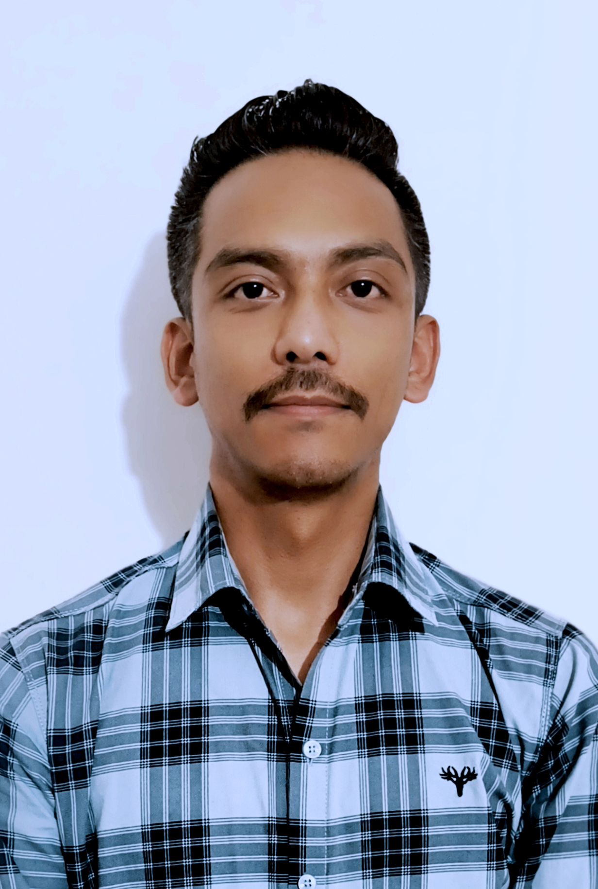

Recent Photograph

Name: - PRATIT TAMANG

Designation: - ASSISTANT PROFESSOR

Date of Birth: - 02.11.1987

Educational Qualification: -
Sl No. | Degree obtained  (Abbreviation of the degree) | College/ university from which the degree was obtained | Year of Passing
 | B.A POLITICAL SCIENCE | ST. JOSEPH’S COLLEGE, DARJEELING | 2009
 | 3 YEARS ADVANCED DILPOMA IN MASS COMMUNICATIONAND JOURNALISM | ST. JOSEPH’S COLLEGE, DARJEELING | 2009
 | M.A POLITCAL SCIENCE | UNIVERSITY OF NORTH BENGAL | 2011

Permanent Address: - Kutchery Compound Below Judge Court, Darjeeling, P.O/P. S Darjeeling, Pin: 734101

Contact Number:- +918597111814

E-mail:- tamangpratit@gmail.com

Date of joining(Service):- July 2014

Specialization:- Political thought and theory
Area of Interest: - Public Health and Healthcare Studies, Social History of Medicine, Identity Politics, Migration Studies, Colonial and Postcolonial Studies.

Faculty Development Programme: -
Sl No. | Year | Name of Programme Participated (OP/ RC/FDP/Summer School/FEP/Others) | Organized By
 | 2018 | Participated in the UGC Sponsored, 36th Orientation Programme from 15th November to 12th December 2018 | UGC-HRDC, University of North Bengal
 | 2020 | Participated in One Week National Level E-STTP on “Research Methodology” from 20th July 2020 to 27th July 2020 | The Faculty of Humanities and Science, Adayalampattu Phase II Campus, Dr. MGR Educational and Research Institute University
 | 2020 | Refresher Course on “Research Methodology for Faculty of Social Sciences” from 5th August 2020 to 19th August 2020 | UGC- HRDC, University of Hyderabad
 | 2022 | Attended 7 days Online Faculty development Program on “Information and Communication Technology: Perspective, Methodology, Implementation” from 5th to 12th March 2022 | Kolkata Society for Asian Studies in association with Sarojini Naidu College for Women and Indian Academic Researchers Association
 | 2024 | Participated in the Short-term Course on “Telemedicine and Digital Health” from 4th March 2024 to 9th March 2024 | UGC Malaviya Mission Teacher Training Centre. NEHU (Shillong)

Paper Presentation: Conferences/Seminars /Symposia /Workshops:-
Sl no. | Year | Title | Organized by | International  /National  / State Level
 | March, 2013 | “Gazing Tibetan Migrations in India” | Centre for Himalayan Studies, University of North Bengal. | National Seminar
 | March, 2013 | “Tibetan Refugee Children and Education as a Right” | Department of Sociology, University of North Bengal in Collaboration with Anthropological Survey of India. | Natonal Seminar
 | 2013 | “Tibetan Refugee Women in Darjeeling: An Economic Perspective” | Centre for Women’s Studies, University of North Bengal | National Seminar
 | December, 2013 | 'History, Culture, Environment and Development: Indian Experiences' | Department of Economics and Political Science, St. Joseph's College, Darjeeling, West Bengal | National Seminar
 | December, 2016 | “One Day Awareness Workshop on NMEICT” | National Institute of Technology, Durgapur and Ministry of Higher Education, Government of West Bengal | National level workshop
 | 2017 | 'Variation and Prospects of Eco-Tourism at Darjeeling and Doors' | Gorubathan Government College, P. O Fagu, Kalimpong | National Seminar
 | September, 2017 | "National Health Policy and Healthcare as a Right" | Department of Political Science, University of North Bengal | National Seminar
 | February, 2018 | "Tribal Health and Healthcare: An Indian Perspective" | Gorubathan Government College, P. O Fagu, Kalimpong. | National Seminar
 | February, 2018 | "Tribal Society and Culture" | Gorubathan Government College, Kalimpong, West Bengal | National Seminar
 | March, 2018 | “Digital Revolution and Healthcare Trends in India", | Islampur College, Islampur, Utter Dinajpur. | International Seminar
 | May, 2023 | “Sisnu: An ethno-medical investigation of the elixiric nettle (Urtica dioica) of the Himalayan region of Darjeeling and Kalimpong" | Cluny Women’s College, Kalimpong. | International Seminar
 | June, 2023 | “Revisiting the Pandemic and Healthcare in Darjeeling and Kalimpong” | Annual Conference of West Bengal Political Science Association (WBPSA) | Annual Conference
 | June, 2023 | "In Search of Healthy Lives: Development, Urbanism and People in North Bengal" | Department of History and Political Science, Birsa Munda College, Naxalbari, Darjeeling. | International Seminar
 | September, 2023 | “Paving the path to equitable healthcare: Overcoming challenges in Gorubathan Block, West Bengal" | Indian Political Science Association (IPSA). | International Seminar

Community Work/Social Activity: -
Sl No. | Member of MARG (Mankind in Action for Rural Growth), an NGO dedicated to combating human trafficking. My involvement includes participating in awareness programs on human trafficking and child sexual abuse, as well as helping to establish the Youth Against Trafficking Club at Gorubathan Government College. Since 2018, I have also served as the nodal officer for the Electoral Literacy Club (ELC), which focuses on enhancing electoral literacy among young voters. Through this role, I work to generate awareness and sensitize students about democracy, elections, and democratic processes.

